CSC-205L Computer Organization & Assembly Language
Dynamic Typing Speed Tester and Analyzer
Section: A
Project Report



Submitted By:
Syed Shayan Arshad 2023-CS-625
Adeel-Ur-Rehman 2023-CS-626
Hammad Khalid 2023-CS-637

Submitted To:
Mam. Rimsha Noreen
Dated: 14th May 2025

Department of Computer Science
University of Engineering and Technology Lahore, New Campus
1. Introduction
1.1 Project Overview
The Dynamic Typing Speed Tester and Analyzer is an assembly language-based application designed to measure and analyze a user’s typing speed and accuracy. Unlike conventional typing test applications built with high-level languages, this project leverages low-level programming using MASM (Microsoft Macro Assembler) to demonstrate efficient resource management, including input/output operations, timer control, and performance metrics calculation. The system provides a user-friendly interface with immediate feedback and detailed performance analysis to help users improve their typing skills.
1.2 Problem Statement
Typing speed and accuracy are essential skills in the digital world, yet most typing test tools lack transparency in low-level operations and may not optimize system resources effectively. This project addresses these limitations by implementing a typing speed test system in assembly language, showcasing the power of low-level programming in handling I/O, timers, and metrics while providing a robust tool for skill assessment.
1.3 Objectives
- Develop a dual-component system with a typing test module and an independent timer module.
- Generate dynamic typing content using a Python script.
- Calculate comprehensive metrics, including Words per Minute (WPM), Characters per Minute (CPM), accuracy, and error analysis.
- Provide flexible test modes (30 seconds, 1 minute, 2 minutes, and no-time-limit).
- Use file-based synchronization for accurate testing flow.
- Deliver a detailed performance report with color-coded output and audio feedback.
1.4 Scope
The project focuses on assembly language programming using MASM and the Irvine32 library, integrated with a Python script for content generation. It supports multiple test modes, detailed metrics, and a user-friendly console interface, making it suitable for educational purposes and skill development.
2. Project Modules Explanation
The project is divided into two main modules, each implemented in a separate file to demonstrate multi-module programming. Below is a detailed explanation of each module, their functionality, and their interaction.
2.1 Typing Test Module
Purpose: Handles user input, displays the typing paragraph, calculates performance metrics, and presents results.
Key Features:
- Menu System: Displays a menu for selecting test modes (30 seconds, 1 minute, 2 minutes, or complete paragraph). Users input a choice (1–4), which determines the test duration and paragraph length.
- Dynamic Content Generation: Executes a Python script (generate_words.py) via ShellExecuteA to generate a paragraph stored in word.txt. The script is called with parameters based on the selected test mode (e.g., /c python generate_words.py 30sec).
- Paragraph Display: Reads the paragraph from word.txt and displays it within a fixed-width (100 characters) bordered console window, positioned at the right-center of the screen using SetWindowPos.
- User Input Handling: Captures user input character by character, supports backspace for corrections, and allows early test termination via the ESC key. Input is stored in a buffer (userInput) and compared to the reference paragraph.
- Metrics Calculation: Computes:
  - Gross WPM: Total characters typed divided by 5, scaled to per-minute rate.
  - Net WPM: Adjusts Gross WPM by subtracting errors (divided by 5).
  - WPM: Based on word count in user input.
  - CPM: Characters typed per minute.
  - Accuracy: Percentage of correct characters.
  - Completion Percentage: Proportion of the paragraph typed.
  - Error Count: Number of mismatched characters.
  - Backspace Count: Number of backspace key presses.
- Results Display: Presents a formatted report with color-coded metrics (e.g., cyan for metrics, green for success) and borders for clarity.
- File Operations: Reads time_setting.txt for test duration, creates sync.txt to signal the timer module, and deletes sync.txt at the start for a fresh run.
Workflow:
- Displays the menu and captures user choice.
- Executes the Python script to generate a paragraph.
- Reads and displays the paragraph from word.txt.
- Creates sync.txt to start the timer module.
- Collects user input, tracks time, and stops on time-out, ESC press, or paragraph completion.
- Calculates and displays metrics in a structured report.
2.2 Timer Module
Purpose: Manages the countdown timer and synchronizes with the typing module.
Key Features:
- Synchronization: Waits for sync.txt to appear (using GetFileAttributesA) before starting the timer, ensuring coordination with the typing module.
- Time Configuration: Reads test duration from time_setting.txt (in milliseconds, converted to seconds). Defaults to 60 seconds if the file is invalid or specifies 0 (no-time-limit mode).
- Countdown Display: Shows remaining time in a console window positioned at the top-left of the screen.
- No-Time-Limit Mode: If time_setting.txt specifies 0, waits for sync.txt to be deleted (indicating test completion) instead of counting down.
- Audio Feedback: Emits a beep (using Beep API) when time expires in timed modes.
- Console Management: Sets a fixed console size (40x7) and draws a border using ASCII characters for a clean interface.
Workflow:
- Displays a “Waiting for typing to start...” message until sync.txt is detected.
- Reads duration from time_setting.txt or uses default (60 seconds).
- For timed modes, counts down seconds, updating the display and checking if sync.txt is deleted (indicating early completion).
- For no-time-limit mode, waits for sync.txt deletion.
- Displays “Time’s up!” or “Typing test completed!” and beeps (if timed out).
2.3 Module Interaction
- Synchronization: The typing module creates sync.txt to signal the timer to start. The timer checks for sync.txt’s existence to proceed or end early (if deleted by the typing module upon completion or ESC press).
- File-Based Communication:
word.txt: Stores the generated paragraph for the typing module.
time_setting.txt: Specifies test duration for both modules.
sync.txt: Facilitates start/stop coordination.
2.4 Supporting Component
Python Script (generate_words.py): Generates random paragraphs based on test mode. Outputs to word.txt and writes duration to time_setting.txt (e.g., 30000 for 30 seconds, 0 for complete mode). This script is executed via ShellExecuteA and is essential for dynamic content.
3. Screenshots of Execution
Menu Screen
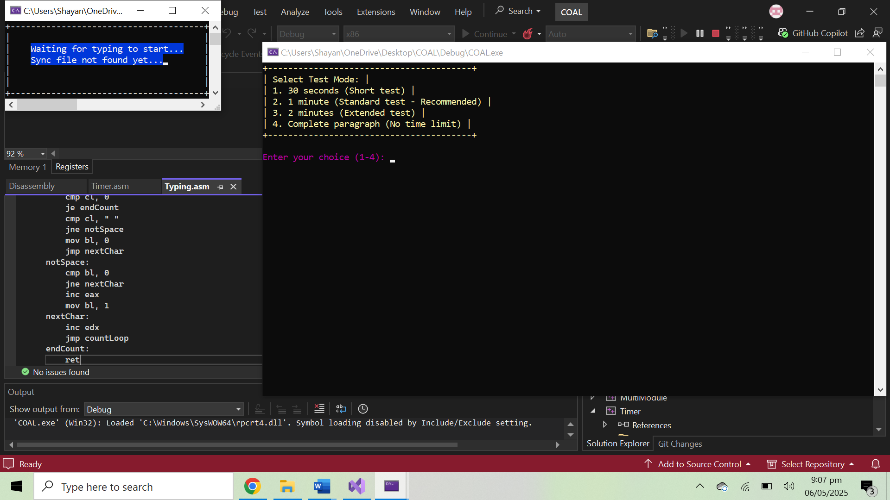

Typing Test Interface
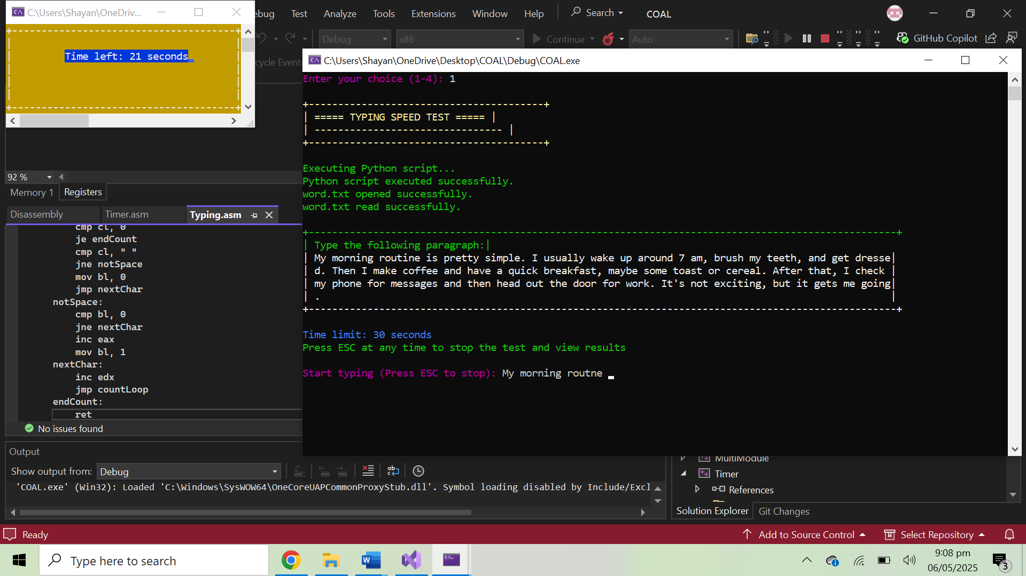
Timer Waiting State
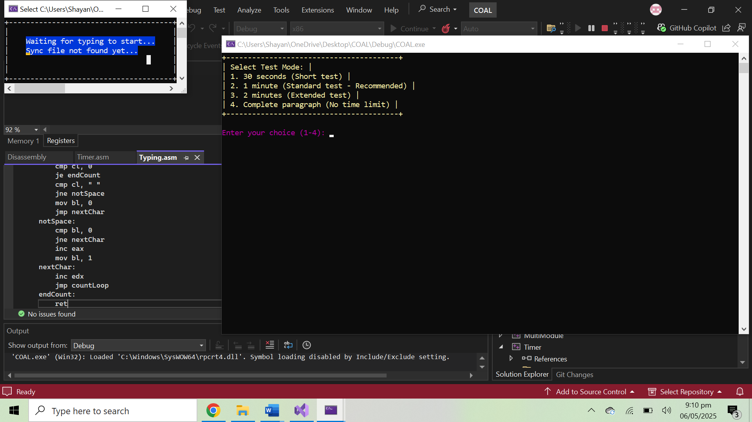
Timer Countdown

Result Screen
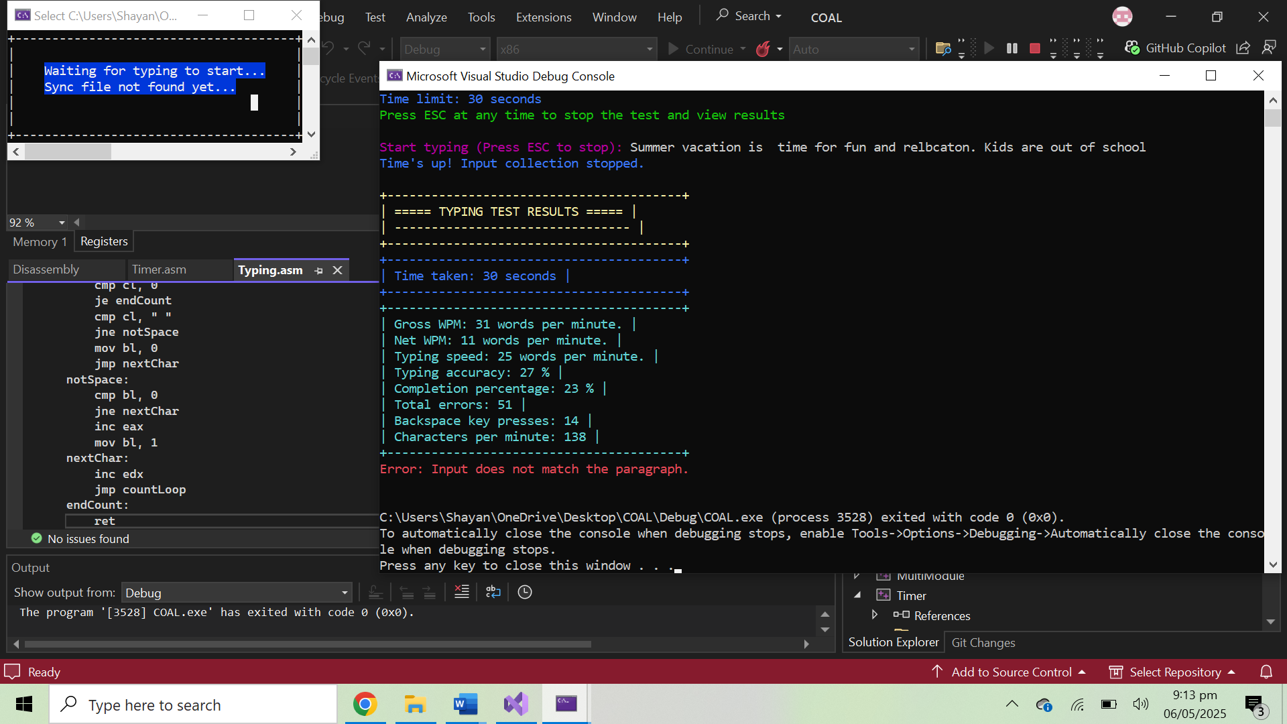
4. Explanation of Assembly Concepts Used
The project employs several core assembly language concepts to achieve its functionality. Below is a detailed explanation of how these concepts are implemented, aligning with the course requirements.
- Multi-Module Structure: The project is split into typing.asm and timer.asm, each handling distinct tasks (typing test and timer). This modular design promotes code organization and reusability.
- Procedures and Parameter Passing: Multiple procedures are defined in both modules, such as DisplaySimpleParagraph (displays paragraph with fixed width), and DrawBorder (draws console borders). Parameters are passed via registers (e.g., ESI, EDX) or the stack.
- Data Movement and Manipulation: Data is moved between registers, memory, and buffers using instructions like MOV, MOVZX, and LEA. String manipulation is used for parsing (time_setting.txt) and comparing user input with the reference text.
- Arrays Implementation: Arrays are used for buffers like userInput and fileBuffer in typing.asm, and timeBuffer (16 bytes) in timer.asm. These are accessed using pointers (ESI, EDI) for reading and writing.
- Conditional and Loop Execution: Conditional jumps (JE, JNE, JG, JL) control program flow, such as checking for sync.txt existence or validating user input. Loops (LOOP, JMP) handle repetitive tasks like countdown and input processing.
- Stack Operations (PUSH, POP): The stack is used to save and restore registers in procedures to prevent data loss. PUSH and POP are used extensively in ParseDecimal, CalculateMetrics, and DisplaySimpleParagraph.
- Windows API IntegrationWindows APIs (ShellExecuteA, Beep, SetWindowPos, CreateFileA, etc.) are invoked to perform system-level tasks, demonstrating assembly’s ability to interface with the operating system.
5. Conclusion
The Dynamic Typing Speed Tester and Analyzer successfully demonstrates the application of assembly language in building a functional and efficient typing test system. By implementing a dual-module architecture, dynamic content generation, and comprehensive metrics, the project showcases low-level programming’s power in resource management and user interaction. The use of file-based synchronization, color-coded output, and audio feedback enhances the user experience, while the adherence to assembly concepts (multi-module structure, procedures, arrays, etc.) fulfills the course’s learning objectives. The project not only serves as an educational tool for understanding assembly language but also provides a practical application for improving typing skills.

